[Month] [Day], [Year]
SENT VIA EMAIL [Adjuster Email]
Adjuster Name
Sample Insurance Company
[Insurer Mailing Address]
[City, TX ZIP]

Our Client: | Jane Doe
Your Insured: | John Roe
Date of Loss: | [YYYY]-[MM]-[DD]
Claim No.: | SAMPLE-CLAIM-0001
Policy No.: | SAMPLE-POLICY-0001
BI Policy Limit: | $250,000 per person
TIME-LIMITED POLICY-LIMITS SETTLEMENT DEMAND
FOR SETTLEMENT PURPOSES ONLY
Dear Adjuster Name,
Our firm represents Jane Doe concerning the injuries she suffered in the motor vehicle collision caused by your insured on February 26, 2026. The purpose of this letter is to make a clear and unequivocal offer to resolve her bodily-injury claim for the full $250,000 per-person limits available under the above policy. Liability is clear, the medical and wage-loss documentation establishes substantial compensatory damages, and the reasonable value of Ms. Doe's claim materially exceeds the available policy limits. This demand is made to provide your insured a meaningful opportunity to resolve the claim within the available limits before suit.
This evaluation is submitted for settlement purposes only. None of the information provided in this offer shall be construed as a waiver of our client's physician-patient privilege, right to privacy, or any other rights or privileges. The enclosed records and billing materials are provided for claim evaluation and settlement purposes and are not intended as a blanket authorization for disclosure or use beyond this claim.

I. THE COLLISION
This case arises out of a violent automobile collision that occurred on February 26, 2026, at approximately 6:20 p.m., at the signal-controlled intersection of Belt Line Road and Midway Road in Addison, Dallas County, Texas. Ms. Doe was operating her 2023 dark-gray Toyota Camry westbound on Belt Line Road and entered the intersection to turn left onto southbound Midway Road on a protected green left-turn arrow. Your insured, John Roe, was operating a 2019 Ford F-150 eastbound on Belt Line Road. Despite facing a steady red traffic signal, Mr. Roe continued into the intersection and struck the front passenger-side corner and passenger-side front quarter of Ms. Doe's vehicle. The impact rotated the Camry and forced it toward the curb. Both vehicles required removal from the scene.
The crash investigation further documented facts that substantially aggravate the exposure in this matter. Mr. Roe admitted consuming alcohol before driving. Officers observed indicia of intoxication, and post-collision breath testing recorded an alcohol concentration of approximately 0.164. He was arrested for driving while intoxicated. An open alcoholic-beverage container was also documented inside his vehicle. These facts are material not only to liability but to the exemplary-damages exposure discussed below.
The following photographs show the condition of Ms. Doe's vehicle after the collision and are consistent with a substantial passenger-front impact:
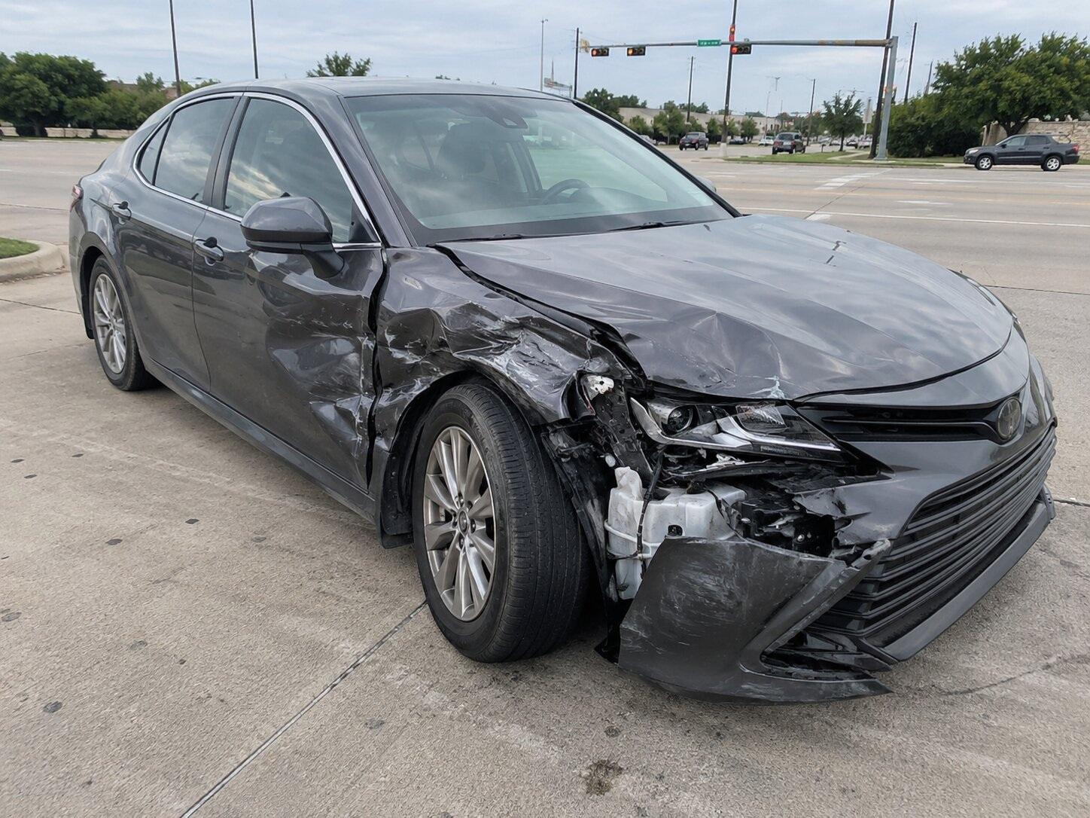 | 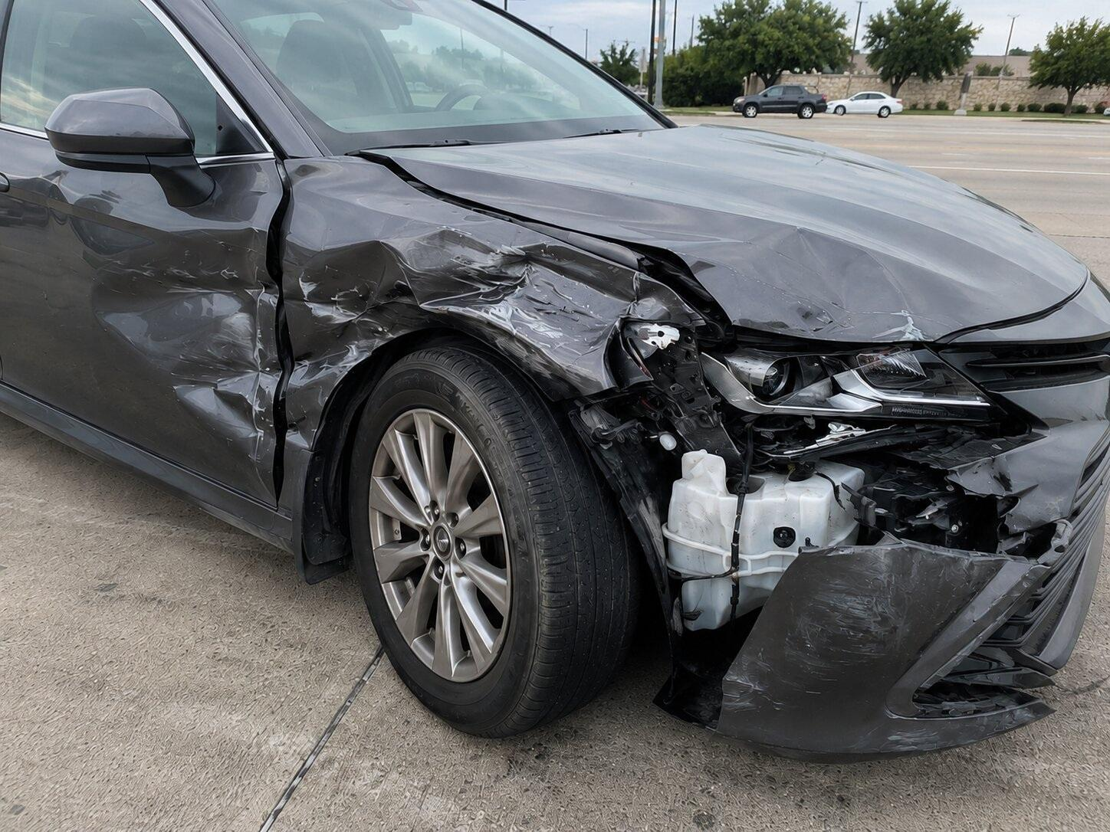
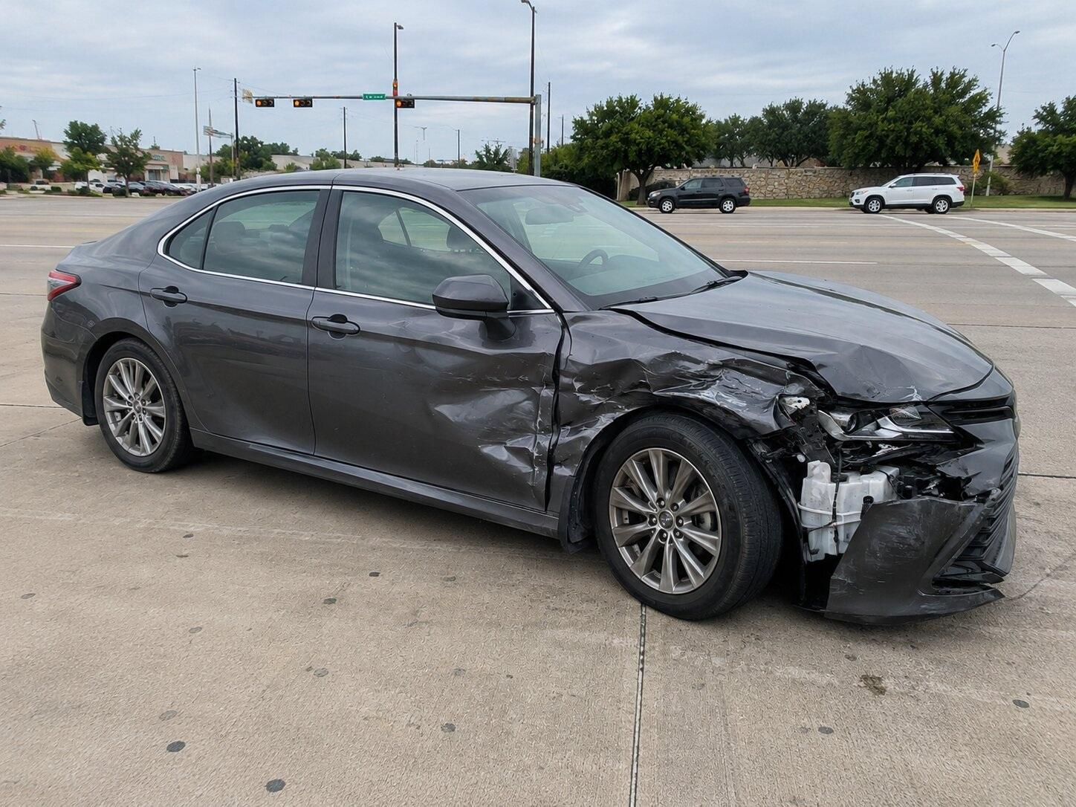

II. LIABILITY
We view this case as one of 100% liability against your insured. Texas Transportation Code § 544.007(c) permits a driver facing a green arrow to cautiously enter the intersection and move in the direction indicated while yielding to traffic lawfully using the intersection. Section 544.007(d), by contrast, requires a driver facing only a steady red signal to stop and remain stopped until an indication to proceed is shown, subject only to the limited turns permitted after stopping and yielding. Ms. Doe entered on a protected green arrow. Mr. Roe entered straight through the intersection against the red signal. His statutory violation and failure to maintain control were direct and proximate causes of the collision.
The available evidence also forecloses the anticipated comparative-responsibility defense. The signal sequence and witness information corroborate Ms. Doe's protected movement. The point and severity of impact are consistent with Mr. Roe entering late and at speed after Ms. Doe had already committed to the turn. There is no evidence that Ms. Doe was speeding, distracted, or otherwise operating unsafely. A motorist proceeding on a protected arrow cannot reasonably be expected to anticipate that an intoxicated driver will disregard a solid red signal and enter the intersection directly into her path.
Mr. Roe's alcohol impairment further strengthens the liability case. Texas Penal Code § 49.04 prohibits operating a motor vehicle in a public place while intoxicated, and Texas Penal Code § 49.01(2)(B) defines intoxication to include an alcohol concentration of 0.08 or more. The reported 0.164 result was more than twice that statutory threshold. The combination of intoxicated driving and a red-signal violation presents compelling evidence that your insured's conduct caused this collision and the resulting injuries.

III. MEDICAL CHRONOLOGY
Jane Doe is a 42-year-old woman who, before this collision, worked full-time in a physically demanding commercial facilities position and managed her household independently. The collision produced immediate neck, thoracic, low-back, headache, cognitive, and anxiety symptoms. Her treatment has included emergency evaluation, medication, active rehabilitation, diagnostic imaging, interventional pain care, cognitive rehabilitation, and trauma-focused psychological treatment. The following summarizes her post-collision course:
February 26, 2026: Ms. Doe presented to Sample Medical Center on the date of loss with neck pain, upper- and low-back pain, headache, nausea, dizziness, and left shoulder soreness after the side/front-quarter impact. She rated her pain 8/10. Examination documented cervical and lumbar tenderness with painful range of motion and paraspinal spasm. CT imaging of the head and cervical spine showed no acute fracture or intracranial hemorrhage. She was diagnosed with acute cervical strain, lumbosacral strain, post-traumatic headache, and concussion without loss of consciousness. She was discharged with anti-inflammatory medication, muscle-relaxant therapy, activity precautions, and instructions for close outpatient follow-up.
February 27, 2026: Ms. Doe presented to Sample Injury & Rehabilitation Center for a comprehensive post-collision evaluation with chief complaints of neck, upper-back, and lumbosacral pain, headaches, brain fog, sleep disruption, and intermittent paresthesias into the left upper extremity. She reported pain of 8/10 and difficulty bending, lifting, turning her head, driving, sleeping, and completing her normal work tasks. Examination demonstrated restricted cervical and lumbar motion, positive cervical compression and facet-loading maneuvers, thoracic hypertonicity, lumbar instability, bilateral sacroiliac tenderness, and pain with provocative hip and lumbar testing. Diagnoses included cervical strain, cervicalgia, thoracic strain, lumbosacral strain, sacroiliitis, concussion, post-concussion syndrome, and bilateral occipital neuralgia. She was placed on modified work duty.
March 2, 2026: At follow-up with Sample Injury & Rehabilitation Center, the emergency imaging was reviewed along with office radiographs. The provider documented persistent loss of normal cervical lordosis, muscle guarding, and early degenerative disc-height changes at C5-C7 and L5-S1. Because Ms. Doe had been functioning at full duty without active spine treatment before the crash, the provider considered the degenerative findings pre-existing but clinically aggravated and made symptomatic by the collision. A plan was established for physical therapy, occupational/cognitive rehabilitation, home exercise, TENS therapy, and cervical and lumbar MRI studies if symptoms persisted. Modified-duty restrictions continued.
March 3, 2026: Ms. Doe underwent a physical therapy initial evaluation at Sample Injury & Rehabilitation Center. She reported worst pain of 9/10, headaches, sleep interruption, fear and anxiety while driving, numbness and tingling in her hands, and difficulty looking over her shoulders. Objective findings included forward-head posture, decreased cervical stability, weakness of the scapular stabilizers and rotator cuff musculature, hypomobility in the upper cervical and thoracic segments, and painful lumbar movement. Her treatment plan emphasized therapeutic exercise, neuromuscular re-education, manual therapy, graded functional activity, and return-to-work tolerance.
March 5-30, 2026: Ms. Doe attended a regular course of physical therapy and rehabilitation at Sample Injury & Rehabilitation Center. Treatment included manual therapy, therapeutic exercise, therapeutic activities, neuromuscular re-education, postural retraining, and a home exercise program. Pain frequently increased to 7-8/10 with activity. She continued to report difficulty sleeping, driving, turning her head, bending, pushing, pulling, lifting, carrying, and performing the repetitive physical demands of her job. She was also fitted with an LSO lumbar brace, a cervical support collar for limited therapeutic use, and a TENS unit for home pain management.
March 6, 2026: Ms. Doe underwent an occupational/cognitive rehabilitation evaluation because of persistent post-concussive symptoms. She described confusion, slowed processing, difficulty focusing, forgetfulness, dizziness with positional changes, and daily headaches. ACE-III cognitive testing produced a score of 74/100, with deficits most apparent in attention, verbal fluency, memory retrieval, and visuospatial tasks. The clinician recommended cognitive pacing strategies, structured task management, sleep hygiene, and continued monitoring of post-concussive symptoms.
March 27, 2026: Cervical and lumbar MRI studies were obtained at Sample Diagnostic Imaging. The cervical MRI demonstrated straightening of the normal cervical lordosis, a small broad-based disc protrusion at C5-6, and a disc bulge at C6-7 with mild foraminal narrowing. The lumbar MRI demonstrated mild multilevel degenerative changes, facet hypertrophy at L4-5, and a small central protrusion with annular fissuring at L5-S1. No acute fracture was identified. The treating providers considered the degenerative component pre-existing, but correlated the new post-collision symptoms, muscle spasm, restricted motion, and facet-mediated pain with a traumatic aggravation of previously non-disabling changes.
April 29, 2026: Ms. Doe presented to Sample Pain & Spine Institute for an interventional pain consultation. She described persistent posterior neck, upper-back, and low-back pain as sharp, tight, and throbbing, with severity up to 8/10. Examination showed painful cervicothoracic and lumbar range of motion, taut paraspinal musculature, positive lumbar facet loading, sacroiliac tenderness, and a positive straight-leg raise for back pain. The provider diagnosed cervicalgia, lumbar strain, lumbar facet-mediated pain, and sacroiliac pain, and expressly related the symptomatic condition to the February 26 collision. Diagnostic lumbar medial branch blocks were recommended.
May 5, 2026: Ms. Doe underwent psychological and neurobehavioral testing at Sample Behavioral Health because driving anxiety, intrusive recollections, sleep disturbance, and cognitive complaints had persisted despite improvement in some physical symptoms.
May 7, 2026: At Sample Pain & Spine Institute, Ms. Doe underwent fluoroscopically guided bilateral lumbar medial branch blocks at L3-L4, L4-L5, and L5-S1 using local anesthetic and corticosteroid medication. She tolerated the procedure without complication and reported substantial temporary reduction in her axial low-back pain, supporting a facet-mediated pain generator.
May 15, 2026: At post-procedure follow-up, Ms. Doe reported approximately 70% temporary improvement in low-back pain after the medial branch block, followed by recurrence with bending, prolonged standing, and work activity. The provider reaffirmed collision-related causation and discussed a confirmatory block followed by radiofrequency ablation if the response remained reproducible.
May 20, 2026: Ms. Doe completed a comprehensive psychological evaluation at Sample Behavioral Health. She described intrusive memories, nightmares, anxiety and freezing while driving, avoidance of unnecessary driving, irritability, hypervigilance, diminished interest in activities, fatigue, poor concentration, and disrupted sleep. Standardized testing produced a PCL-5 score of 49, a GAD-7 score of 18, and a PHQ-9 score of 14. The psychologist diagnosed post-traumatic stress disorder with associated anxiety and depressive symptoms and identified the motor vehicle collision as the precipitating traumatic event. A course of trauma-focused psychotherapy was recommended.
May 28, 2026: Sample Pain & Spine Institute reevaluated Ms. Doe for persistent lumbar and sacroiliac pain. She remained functionally limited despite rehabilitation and the temporary benefit from the first diagnostic block. The plan included a confirmatory medial branch block, possible lumbar radiofrequency ablation, and bilateral sacroiliac joint injections if symptoms continued.
June 1, June 8, June 22, and July 6, 2026: Ms. Doe participated in individual trauma-focused psychotherapy at Sample Behavioral Health. Sessions addressed accident-related re-experiencing, autonomic arousal while driving, avoidance, sleep disruption, irritability, grounding techniques, paced breathing, and gradual return to independent driving. She improved in her use of coping skills but continued to experience clinically significant anxiety and sleep disturbance.
July 13, 2026: Sample Injury & Rehabilitation Center completed a rehabilitation discharge/MMI evaluation. Ms. Doe had improved from her acute presentation but continued to report neck pain of approximately 4/10 and low-back pain of approximately 5/10 with prolonged activity. Range of motion and work tolerance had improved but had not returned to baseline. The provider concluded that she had reached a plateau and maximum medical improvement from active conservative rehabilitation, while specifically noting that interventional pain care and behavioral-health treatment remained medically appropriate.
July 16, 2026: At her most recent pain-management follow-up, Ms. Doe continued to report activity-dependent lumbar pain, intermittent cervical pain and headaches, and difficulty tolerating repetitive lifting and prolonged standing. The provider recommended proceeding with the second diagnostic lumbar block and, if again successful, bilateral radiofrequency ablation. Continued psychotherapy and a limited maintenance rehabilitation program were also recommended. Her prognosis was characterized as guarded-to-fair for complete resolution but favorable for additional functional improvement with the recommended care.

IV. INJURIES
The following diagnoses and conditions have been documented in connection with the collision:
Injuries and Conditions: | Diagnosis Code
Cervical strain | S16.1XXA
Cervicalgia | M54.2
Thoracic strain | S29.012A
Pain in thoracic spine | M54.6
Lumbosacral strain | S39.012A
Low back pain | M54.50
Lumbar radiculopathy / radiating lumbar symptoms | M54.16
Bilateral sacroiliitis | M46.1
Bilateral occipital neuralgia | M54.81
Concussion without loss of consciousness | S06.0X0A
Post-concussion syndrome | F07.81
Post-traumatic stress disorder | F43.10
Generalized anxiety | F41.1
Depressive symptoms / depressive disorder | F32.A
Sleep disturbance / insomnia | G47.00
Paravertebral muscle spasm | M62.838
Aggravation of cervical and lumbar degenerative disc disease | M50.30 / M51.36

Pre-Existing Condition and Causation
The cervical and lumbar imaging includes mild degenerative findings that pre-date the collision. Those findings do not explain away Ms. Doe's post-collision condition. Before February 26, 2026, she was working full duty in a physically demanding job, driving independently, maintaining her household, and was not engaged in active spine treatment. The records reflect only a remote episode of self-limited low-back discomfort several years earlier, with no sustained restrictions or interventional care. The collision produced an immediate and materially different symptom pattern involving acute neck and low-back pain, headaches, post-concussive complaints, new functional restrictions, and later psychological trauma.
Her treating providers repeatedly correlated the onset and persistence of symptoms with the collision and treated the degenerative findings as conditions that were rendered symptomatic or aggravated by trauma. The temporal relationship, objective muscle spasm and range-of-motion loss, MRI findings in the symptomatic regions, reproducible facet-mediated pain, response to diagnostic block, and absence of comparable pre-collision functional limitation all support traumatic causation and aggravation.

V. ECONOMIC DAMAGES

A. Medical Expenses
The following represents Ms. Doe's medical expenses to date:
CPT Code | Charges Description | Date | Amount
Healthcare Provider: SAMPLE MEDICAL CENTER
99285 | Emergency Department Visit, High Complexity | 02/26/2026 | $3,250.00
70450 | CT Head/Brain Without Contrast | 02/26/2026 | $1,650.00
72125 | CT Cervical Spine Without Contrast | 02/26/2026 | $1,850.00
73030 | Radiologic Examination, Shoulder | 02/26/2026 | $450.00
71046 | Radiologic Examination, Chest, 2 Views | 02/26/2026 | $400.00
96372 | Therapeutic/Diagnostic Injection | 02/26/2026 | $325.00
J1885 | Injection, Ketorolac Tromethamine | 02/26/2026 | $75.00
L0120 | Cervical Orthosis | 02/26/2026 | $325.00
99070 | Supplies and Materials | 02/26/2026 | $870.00
Subtotal for SAMPLE MEDICAL CENTER: |  |  | $9,195.00
Healthcare Provider: SAMPLE INJURY & REHABILITATION CENTER
99080 | Special Reports/Forms | 02/27/2026 | $750.00
99205 | New Patient Office/Outpatient Visit, High Complexity | 02/27/2026 | $2299.50
72070 | Radiologic Examination, Spine, Thoracic | 02/27/2026 | $307.20
72110 | Radiologic Examination, Lumbosacral Spine, Minimum 4 Views | 02/27/2026 | $483.00
72052 | Radiologic Examination, Cervical Spine, Complete | 02/27/2026 | $575.80
99215 | Established Patient Office Visit, High Complexity | 03/02/2026 | $1866.20
99080 | Special Reports/Forms | 03/02/2026 | $750.00
97161 | Physical Therapy Evaluation, Low Complexity | 03/03/2026 | $955.60
97530 | Therapeutic Activities | 03/05/2026 | $338.40
97112 | Neuromuscular Re-Education | 03/05/2026 | $317.70
97110 | Therapeutic Exercises | 03/05/2026 | $282.20
97140 | Manual Therapy Techniques | 03/05/2026 | $269.20
97165 | Occupational Therapy Evaluation, Low Complexity | 03/06/2026 | $980.10
97530 | Therapeutic Activities | 03/09/2026 | $338.40
97112 | Neuromuscular Re-Education | 03/09/2026 | $317.70
97110 | Therapeutic Exercises | 03/09/2026 | $282.20
97140 | Manual Therapy Techniques | 03/09/2026 | $269.20
97530 | Therapeutic Activities | 03/11/2026 | $338.40
97112 | Neuromuscular Re-Education | 03/11/2026 | $317.70
97110 | Therapeutic Exercises | 03/11/2026 | $282.20
97140 | Manual Therapy Techniques | 03/11/2026 | $269.20
97530 | Therapeutic Activities (2 Units) | 03/12/2026 | $676.80
97112 | Neuromuscular Re-Education | 03/12/2026 | $317.70
97110 | Therapeutic Exercises | 03/12/2026 | $282.20
L0650 | Lumbar-Sacral Orthosis (LSO) | 03/12/2026 | $9046.60
97112 | Neuromuscular Re-Education (2 Units) | 03/16/2026 | $635.40
97530 | Therapeutic Activities | 03/16/2026 | $338.40
97110 | Therapeutic Exercises | 03/16/2026 | $282.20
97112 | Neuromuscular Re-Education (2 Units) | 03/18/2026 | $635.40
97530 | Therapeutic Activities | 03/18/2026 | $338.40
97110 | Therapeutic Exercises | 03/18/2026 | $282.20
97112 | Neuromuscular Re-Education (2 Units) | 03/19/2026 | $635.40
97530 | Therapeutic Activities | 03/19/2026 | $338.40
97110 | Therapeutic Exercises | 03/19/2026 | $282.20
L0180 | Cervical Multiple Post Collar | 03/23/2026 | $4289.50
97530 | Therapeutic Activities (2 Units) | 03/23/2026 | $676.80
97112 | Neuromuscular Re-Education | 03/23/2026 | $317.70
97110 | Therapeutic Exercises | 03/23/2026 | $282.20
97112 | Neuromuscular Re-Education (2 Units) | 03/25/2026 | $635.40
97530 | Therapeutic Activities | 03/25/2026 | $338.40
97110 | Therapeutic Exercises | 03/25/2026 | $282.20
97112 | Neuromuscular Re-Education (2 Units) | 03/26/2026 | $635.40
97530 | Therapeutic Activities | 03/26/2026 | $338.40
97110 | Therapeutic Exercises | 03/26/2026 | $282.20
E0730 | TENS Unit, Four Or More Leads | 03/30/2026 | $707.70
A4595 | Electrical Stimulator Supplies | 03/30/2026 | $122.50
97530 | Therapeutic Activities (2 Units) | 03/30/2026 | $676.80
97112 | Neuromuscular Re-Education | 03/30/2026 | $317.70
97110 | Therapeutic Exercises | 03/30/2026 | $282.20
99214 | Established Patient Office/Outpatient Re-Evaluation | 07/13/2026 | $450.00
Subtotal for SAMPLE INJURY & REHABILITATION CENTER: |  |  | $37,316.30
Healthcare Provider: SAMPLE DIAGNOSTIC IMAGING
72141 | MRI Cervical Spine Without Contrast | 03/27/2026 | $2,425.00
72148 | MRI Lumbar Spine Without Contrast | 03/27/2026 | $2,425.00
Subtotal for SAMPLE DIAGNOSTIC IMAGING: |  |  | $4,850.00
Healthcare Provider: SAMPLE PAIN & SPINE INSTITUTE
64493 | Injection, Diagnostic/Therapeutic Agent, Paravertebral Facet Joint, Lumbar/Sacral, 1 Level | 05/07/2026 | $783.60
64494 | Injection, Diagnostic/Therapeutic Agent, Paravertebral Facet Joint, Lumbar/Sacral, 2nd Level | 05/07/2026 | $294.75
99203 | Office/Outpatient New, Low MDM, 30-44 Minutes | 05/07/2026 | $2050.00
99212 | Office/Outpatient Established | 05/07/2026 | $1450.00
64495 | Injection, Diagnostic/Therapeutic Agent, Paravertebral Facet Joint, Lumbar/Sacral, 3+ Level | 05/07/2026 | $1350.00
99070 | Supplies; Procedure Tray | 05/07/2026 | $90.00
J0665 | Injection, Bupivacaine, NOS, 0.5mg | 05/07/2026 | $7.20
J2003 | Injection, Lidocaine HCl, 1 mg | 05/07/2026 | $10.00
J1010 | Injection, Methylprednisolone Acetate 1 mg | 05/07/2026 | $53.60
99441 | Physician/QHP Telephone Evaluation 5-10 Min | 05/15/2026 | $273.10
99441 | Physician/QHP Telephone Evaluation 5-10 Min | 05/28/2026 | $273.10
99213 | Established Patient Office/Outpatient Follow-Up | 07/16/2026 | $350.00
Subtotal for SAMPLE PAIN & SPINE INSTITUTE: |  |  | $6,985.35
Healthcare Provider: SAMPLE BEHAVIORAL HEALTH
96138 | Psychological Testing 1st 30 Minutes | 05/05/2026 | $236.60
96139 | Psychological Testing 2nd 30 Minutes | 05/05/2026 | $243.43
90791 | Mental Health Assessment/Diagnostic Interview | 05/20/2026 | $1184.94
96130 | Testing Evaluation | 05/20/2026 | $813.37
96116 | Neurobehavioral Status Exam | 05/20/2026 | $799.25
90837 | Individual Psychotherapy 60 Min | 06/01/2026 | $895.67
90837 | Individual Psychotherapy 60 Min | 06/08/2026 | $895.67
90837 | Individual Psychotherapy 60 Min | 06/22/2026 | $895.67
90837 | Individual Psychotherapy 60 Min | 07/06/2026 | $895.67
Subtotal for SAMPLE BEHAVIORAL HEALTH: |  |  | $6,860.27
Total Medical Expenses: |  |  | $65,206.92

B. Future Medical Expenses
Ms. Doe has been recommended for additional care directly related to the collision. Based on the treatment plan and the response to her first diagnostic procedure, the anticipated future care includes:
- Second diagnostic bilateral lumbar medial branch block - $5,200.00
- Bilateral lumbar radiofrequency ablation if the confirmatory block is successful - $12,500.00
- Bilateral sacroiliac joint injections - $4,800.00
- Eight maintenance physical-therapy visits - $1,600.00
- Ten additional trauma-focused psychotherapy sessions - $2,500.00
- Neurobehavioral/cognitive follow-up evaluation - $1,250.00
- Four pain-management follow-up visits - $1,000.00
- Medication and adjunctive pain-management costs over approximately 18 months - $2,240.00
- Cervical epidural steroid injection if radicular symptoms persist - $3,000.00
The estimated future medical expense is approximately $34,090.00. These amounts are conservative planning figures based on the type of care recommended and are separate from the medical expenses already incurred.

C. Punitive Damages
In addition to the compensatory damages outlined above, we believe a jury could award exemplary damages under Texas Civil Practice and Remedies Code §§ 41.001(11) and 41.003 based on your insured's gross negligence. Texas law defines gross negligence to include conduct that, viewed objectively, involves an extreme degree of risk and of which the actor has actual, subjective awareness but nevertheless proceeds with conscious indifference to the rights, safety, or welfare of others. Here, Mr. Roe chose to operate a motor vehicle after consuming alcohol to the point that post-collision testing reflected an alcohol concentration of approximately 0.164, then proceeded through a steady red traffic signal into a protected-turning vehicle.
The decision to drive while substantially impaired, combined with the disregard of a red traffic signal, presents evidence from which a jury could find both an extreme degree of risk and conscious indifference to the safety of other motorists. Accordingly, if litigation becomes necessary, Ms. Doe will seek exemplary damages in addition to all compensatory damages, subject to the standards and limitations applicable under Chapter 41 of the Texas Civil Practice and Remedies Code.

D. Lost Wages
At the time of the collision, Ms. Doe worked as a commercial facilities technician earning $28.00 per hour for a regular 40-hour workweek. Her physician initially removed her from work for two full weeks, resulting in $2,240.00 in lost earnings. She then returned on restricted duty and, because of documented limits on lifting, bending, prolonged standing, and driving, averaged approximately 20 fewer paid hours per week for the next sixteen weeks, resulting in an additional $8,960.00 in wage loss. Employer verification and payroll records support a total past wage-loss claim of $11,200.00.

VI. NON-ECONOMIC DAMAGES

A. Pain and Physical Suffering
As a direct result of the collision, Ms. Doe has endured months of significant cervical, thoracic, and lumbar pain, headaches, muscle spasm, and activity-related pain that reached 9/10 during the acute phase. She has required emergency evaluation, repeated rehabilitation, home medical equipment, diagnostic MRI studies, and invasive bilateral lumbar medial branch injections. Although conservative treatment produced improvement, she continues to experience neck and low-back pain with repetitive activity, prolonged standing, driving, and lifting. Her sleep has repeatedly been interrupted by pain, and ordinary movements that were once automatic now require pacing and modification.
Given the severity, duration, objective treatment requirements, and persistence of her physical symptoms, we believe a jury could reasonably award $65,000 for past and future physical pain and suffering.

B. Emotional and Psychological Impact
The psychological consequences have been substantial. Ms. Doe developed intrusive recollections, nightmares, hypervigilance, irritability, avoidance, and pronounced anxiety while driving. She reported periods of freezing behind the wheel and initially relied on family members for transportation. Formal testing supported clinically significant post-traumatic stress, anxiety, and depressive symptoms, and she has required psychological evaluation and trauma-focused therapy. The collision also produced cognitive complaints involving attention, memory, processing speed, and mental fatigue during the early recovery period.
Although therapy has provided coping tools, she has not returned to her pre-collision psychological baseline. We believe a jury could reasonably award $65,000 for the emotional and psychological harm caused by the collision.

C. Loss of Function and Daily Life Disruption
Before the collision, Ms. Doe worked full time in a job requiring frequent standing, bending, lifting, carrying, and driving between commercial properties. She independently managed shopping, cleaning, cooking, laundry, errands, and routine family responsibilities. After the collision, those activities became painful, slower, or temporarily impossible. She missed work, returned only with restrictions, reduced her hours, stopped recreational exercise for an extended period, and relied on others for transportation when driving anxiety was most severe. Prolonged computer work, looking over her shoulder, lifting supplies, vacuuming, carrying groceries, and standing through a full work shift have all required modification.
Even at rehabilitation discharge, she had not regained her pre-collision endurance or comfort. We believe a jury could reasonably award $65,000 for physical impairment, loss of function, inconvenience, and disruption of daily life.

VII. DAMAGES SUMMARY

A. Economic Damages
- Past Medical Expenses: $65,206.92
- Future Medical Expenses: $34,090.00
- Lost Wages: $11,200.00
- Economic Damages Subtotal: $110,496.92

B. Non-Economic Damages
- Pain and Physical Suffering: $65,000.00
- Emotional and Psychological Impact: $65,000.00
- Loss of Function and Daily Life Disruption: $65,000.00
- Non-Economic Damages Subtotal: $195,000.00

C. Total Compensatory Damages
- $305,496.92
The foregoing total does not include exemplary damages. The compensatory valuation alone exceeds the $250,000 available per-person bodily-injury policy limit.

VIII. DEMAND FOR SETTLEMENT
This letter represents an opportunity to resolve our client's claim without the need for litigation. We hereby demand policy limits of $250,000 related to any applicable insurance. Our client will also agree to satisfy any valid liens from the settlement proceeds.
If an offer is not extended within ten (10) days of this letter by 1 p.m. Central Time, we will assume the matter cannot be resolved pre-suit and a lawsuit will be filed. We look forward to your prompt response.
Sincerely,
/s/ Attorney Name
Attorney Name
Law Firm Name
Enc. Exhibits A-E

EXHIBIT INDEX
- Medical Bills
- Sample Medical Center - Billing
- Sample Injury & Rehabilitation Center - Billing
- Sample Diagnostic Imaging - Billing
- Sample Pain & Spine Institute - Billing
- Sample Behavioral Health - Billing

- Medical Records
- Sample Medical Center - Records
- Sample Injury & Rehabilitation Center - Records
- Sample Diagnostic Imaging - MRI Reports
- Sample Pain & Spine Institute - Records
- Sample Behavioral Health - Records

- Texas Peace Officer's Crash Report and DWI-related investigation materials

- Vehicle Damage Photographs

- Sample Property Services - Wage Verification and Payroll Documentation

Exhibit materials themselves are intentionally omitted from this public sample.

